LECTURE-16 TREES-1

LEARNING ABOUT RECURSION AND BINARY SEARCH TREES



* All the Binary search tree elements will result in ascending when in-order traversal is done



* In-order traversal is Left Root And Right

HOW TO DRAW A VALID SEARCH TREE IN < 30 SECONDS



* Take an array in ascending order

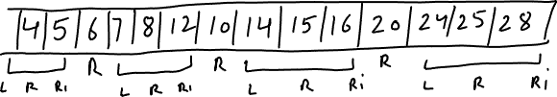

Start filling the branches from the end

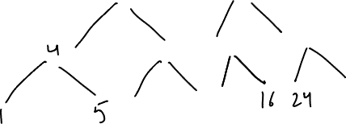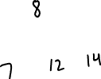

HOW TO CHECK IF A GIVEN TREE IS A VALID BST?

* Simply do a in-order traversal and see if the elements are in ascending order